Water Jug Problem
Aim
To solve the Water Jug Problem using Artificial Intelligence state-space search.
Objective
To obtain the desired quantity of water using two jugs of different capacities.
Algorithm
- Start.
- Read the capacities of Jug 1 and Jug 2.
- Read the target amount.
- Initialize the queue with the initial state (0,0).
- Generate all possible next states.
- Check whether the target amount is reached.
- If reached, print the solution path.
- Otherwise, continue searching until the queue becomes empty.
- If no solution exists, display a message.
- Stop.
Flowchart
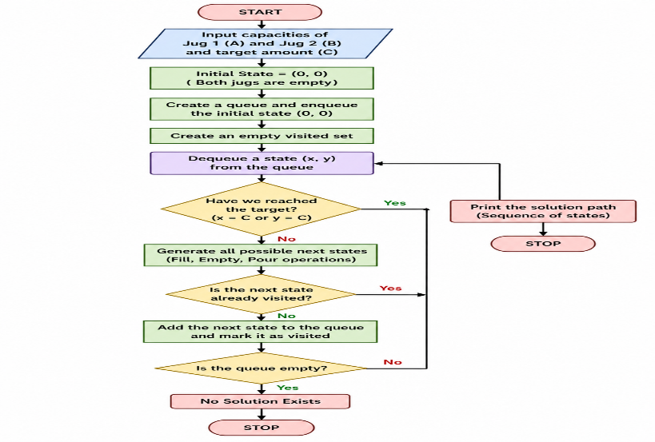

Python Code:
from collections import deque

def water_jug(jug1, jug2, target):

visited = set()
queue = deque()

queue.append((0, 0))
visited.add((0, 0))

while queue:

x, y = queue.popleft()

print("Jug1 =", x, "Jug2 =", y)

if x == target or y == target:
print("\nTarget Reached!")
return

next_states = [

(jug1, y), # Fill Jug1
(x, jug2), # Fill Jug2
(0, y), # Empty Jug1
(x, 0), # Empty Jug2

(max(0, x - (jug2 - y)), min(jug2, y + x)), # Pour Jug1 -> Jug2
(min(jug1, x + y), max(0, y - (jug1 - x))) # Pour Jug2 -> Jug1
]

for state in next_states:
if state not in visited:
visited.add(state)
queue.append(state)

print("No Solution Exists")

jug1 = int(input("Enter capacity of Jug1: "))
jug2 = int(input("Enter capacity of Jug2: "))
target = int(input("Enter target amount: "))

water_jug(jug1, jug2, target)

Output:
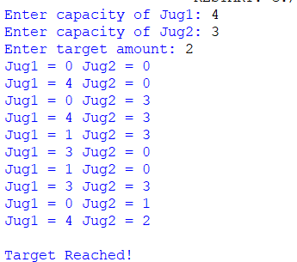
Result:
The target quantity of water was successfully obtained.

Conclusion:
The Water Jug Problem was solved using state-space search techniques.

